NASTP Institute of Information Technology


Submitted To: Sir Hammad

Submitted By: Huzaifa Hassan

Rollno : S2025AI036

Semester: 4th Semester – Fall 2026

Subject: ML LAB

LAB REPORT 4
Course: Machine Learning Laboratory
Lab Number: 04
Title: Tabular Data Manipulation with Pandas: Diagnostics, Subsetting, Imputation, and Transformations
Date: 18 October 2026
1. OBJECTIVE
To load and diagnose tabular movie data using Pandas, identify structural anomalies (null fields, zero placeholders, memory footprint disparities), apply multi-criteria boolean filtering and sequence queries, perform selective feature pruning, impute missing and corrupted numerical/categorical values, and re-index the dataset for label-based retrieval using .loc.
2. THEORY
- Pandas DataFrame Architecture: A two-dimensional, size-mutable tabular data structure with labeled axes (rows and columns). Internally, columns are backed by homogeneous NumPy arrays or extension arrays (e.g., Python object pointers for arbitrary strings).
- Metadata Diagnostics:
  - .info(): Summarizes row count, column identifiers, non-null counts, and memory footprint.
  - .describe(): Calculates five-number summaries along with central tendencies (mean, standard deviation). Significant discrepancies between median and maximum indicate right-skewness and extreme outliers.
  - .memory_usage(deep=True): Calculates true memory allocation. String/text columns stored as object data types consume disproportionately more memory due to dynamic Python string pointer overhead compared to fixed-width primitive blocks (e.g., float64, int64).
- Boolean Masking & Relational Filtering:
  - Vectorized logical operations (&, |, ~) evaluate element-wise without Python-level loops.
  - .isin([list]): Evaluates set membership per entry in $O\left(1\right)$ average time per row.
- Data Cleaning & Imputation:
  - Continuous values: Missing entries ($\text{NaN}$) are commonly imputed with central measures ($\text{mean}$ or robust $\text{median}$).
  - Domain-specific missing flags: Zeros in positive-bounded features (e.g., movie budgets) indicate unrecorded entries rather than genuine zero expenditure; leaving them uncorrected skews regression baselines.
- Label-Based vs Positional Indexing: Changing index labels via .set_index() transforms lookup performance from $O\left(N\right)$ linear scanning to $O\left(1\right)$ hash-map retrieval using .loc[label].
3. TOOLS / SOFTWARE / LIBRARIES
- Operating Environment: Jupyter Notebook / Interactive Python Shell
- Language: Python 3.x
- Core Libraries: Pandas (import pandas as pd), NumPy (import numpy as np)
- Target Dataset: TMDB 5000 Movies Dataset (tmdb_5000_movies.csv)
4. PROCEDURE / METHODOLOGY
- Problem 1 (Data Diagnostics):
  - Loaded the movie records into a DataFrame via pd.read_csv().
  - Executed .info() and computed column-wise missing percentages using df.isnull().mean() * 100.
  - Evaluated distribution statistics for the budget column via .describe() to assess variance and outlier impact.
  - Examined system memory allocation via .memory_usage(deep=True) to contrast string object pointers (overview) with 64-bit numerical primitives (budget).
- Problem 2 (Targeted Extraction):
  - Formulated a compound boolean query ((vote_average > 8.0) & (popularity < 20)) to extract low-exposure, high-rated titles.
  - Filtered records where original_language matches Hindi, Korean, or Japanese using .isin(['hi', 'ko', 'ja']).
  - Constructed an unprofitable release filter (revenue < budget), computed total subset occurrences, and calculated its percentage relative to the overall dataset size.
- Problem 3 (Data Surgery & Transformation):
  - Applied univariate mean imputation to missing values in runtime using .fillna().
  - Assigned constant sentinel string "No Tagline" to replace $\text{NaN}$ fields in tagline.
  - Pruned high-sparsity/unstructured features (homepage, keywords) using .drop(columns=[...]).
  - Reassigned DataFrame primary index to the unique key id using .set_index('id'), followed by label indexing (.loc[19995]) to extract original_title.
  - Isolated zero-value anomalies in budget, computed the median of positive, valid budgets, and imputed zeros with this median.
5. OBSERVATIONS
- String-heavy columns (overview, tagline) consume substantially more RAM than numeric columns (budget, revenue) due to Python pointer overhead in generic object dtypes.
- The budget column displays extreme positive skewness; the maximum value is many orders of magnitude higher than both the mean and the 50th percentile (median).
- The raw budget column contains numerous literal 0 values. While not marked as standard IEEE $\text{NaN}$ values, they represent omitted data that severely drags down mathematical metrics if not filtered or imputed.
- Setting a unique identifier as the DataFrame index provides direct $O\left(1\right)$ query access through .loc[].
6. ANALYSIS / DISCUSSION
- Feature Pruning Justification: homepage exhibits massive missingness and acts purely as metadata without generalized predictive power, making removal appropriate. Conversely, revenue—despite containing zeros—serves as a primary financial metric and target label for predictive tasks; discarding it would discard valid evaluation targets.
- Outlier & Zero Impact on ML: Gradient-based algorithms (e.g., Linear Regression, Neural Networks) update model weights proportionally to input scale:
$$Δw∝\left(y-\overset{ˆ}{y}\right)⋅x$$
An unnormalized feature spanning from $0$ to hundreds of millions causes erratic gradient steps, gradient explosion, and biased weight updates toward extreme magnitude values. Imputing zero budgets with median values rather than the mean preserves central tendency without letting extreme multi-million-dollar blockbusters distort the replacement baseline.
7. CONCLUSION
Essential exploratory analysis, boolean subset extraction, and preprocessing operations were executed using Pandas. The lab highlighted critical distinctions between explicit nulls ($\text{NaN}$) and implicit nulls (numeric zeros), confirmed the memory profile differences across dtypes, and established proper imputation strategies required prior to downstream machine learning ingestion.

Task 1
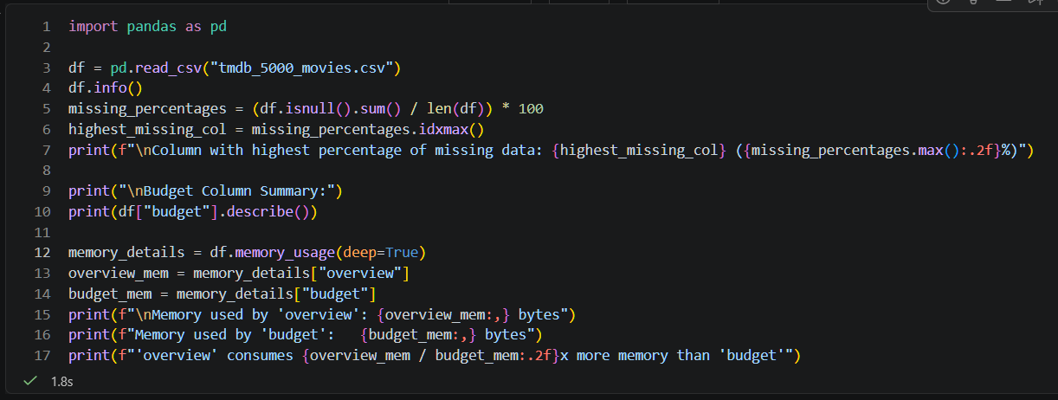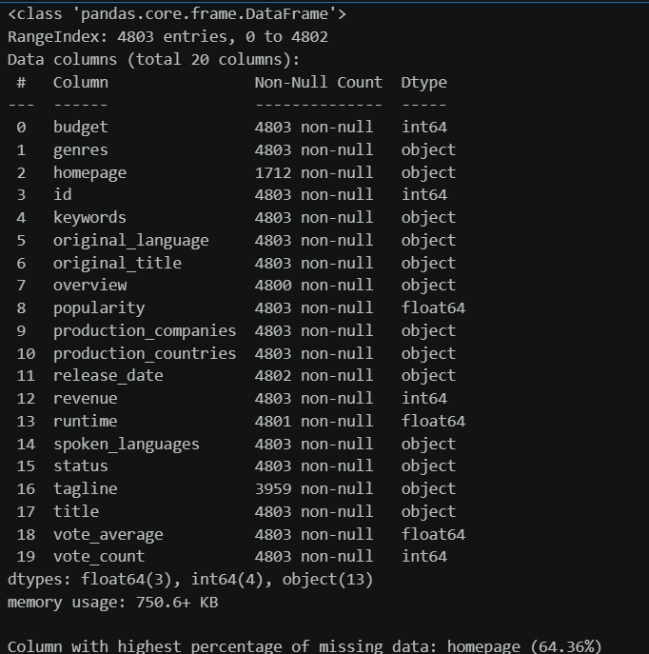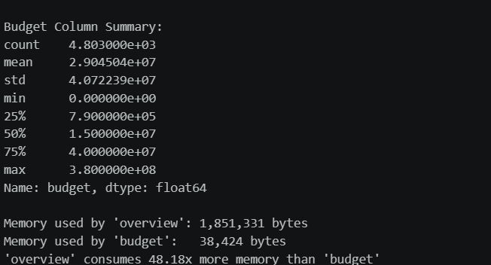

Task2
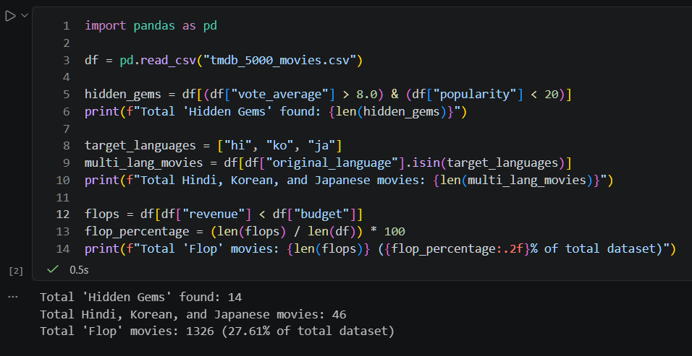

Task3